GIT - PROJECT

# Problem Statement:

Build a branching model as depicted in this figure

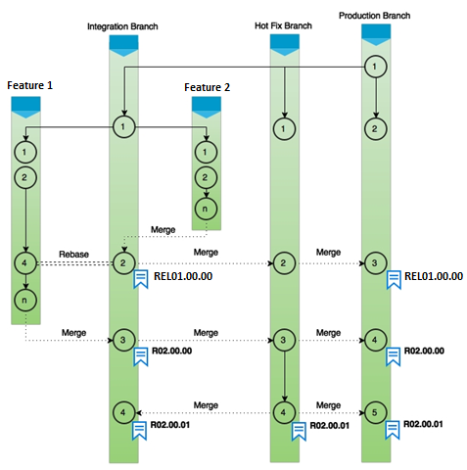

1. Start with the production branch and then create a HotFix branch and Integration branch
2. Subsequently have Feature 1 and 2 branches that integrate as shown in figure
3. Ultimately integrate all features into HotFix branch and then to Production branch

119 mkdir mygitproject

120 cd mygitproject/

121 git status

122 git init

123 git status

124 clear

125 git branch -l

126 git branch hotfix

127 touch index.html

128 vi index.html

129 git log --oneline

130 git add .

131 git commit index.html -m "Adding initial file"

132 git log --oneline

133 git checkout -b hotfix

134 git checkout master

135 git checkout -b integration

136 git checkout master

137 git checkout integration

138 git checkout -b feature-1

139 git checkout integration

140 git checkout -b feature-2

141 git checkout master

142 git branch -l

143 git checkout feature-2

144 ll

145 touch 1.txt

146 echo "This is 1" >> 1.txt

147 touch 2.txt

148 echo "This is 2" >> 2.txt

149 git status

150 git add ..

151 git add .

152 git commit -m "Adding new files"

153 git status

154 git checkout feature-1

155 touch 3.txt

156 echo "This is 3" >> 3.txt

157 git add .

158 git commit -m "Adding new files"

159 git status

160 git checkout integration

161 ll

162 git merge feature-2 integration

163 ll

164 git status

165 git log --oneline

166 git checkout feature-1

167 touch 4.txt

168 echo "This is 4 " >> 4.txt

169 git add .

170 git commit -m "Adding new files 4 "

171 git status

172 git log --oneline

173 git rebase integration

174 git log --oneline

175 ll

176 git checkout integration

177 git merge feature-1

178 ll;

179 git checkout hotfix

180 git status

181 git log -- oneline

182 git log --oneline

183 git merge integration

184 git log --oneline

185 git checkout master

186 git log --oneline

187 git merge hotfix

188 git log --oneline

